Long-term monitoring advice sheet for individuals with cardiorenal disease on RAASi* therapy with hyperkalaemia
Two key aims:
1 | The optimisation of RAASi therapies for cardiorenal protection | 2 | The prevention and management of hyperkalaemia

All individuals with cardiorenal disease require regular monitoring
✓ Continued optimisation of care ✓ Detection of progress of disease or co-morbidities ✓ Discussion of any new advances in care¹
Monitoring MUST include  ✓ Clinical review, e.g. blood pressure, fluid status, risk prediction tools, symptoms  ✓ Medication review, e.g. assess need to start/stop/alter doses, adherence, side effects  ✓ Blood monitoring, e.g. potassium and renal function  ✓ Other relevant investigations, e.g. ECG, echo | Frequency of monitoring  ✓ Frequency of monitoring is determined by the underlying cardiorenal condition and its stage/severity, as well as co-morbidities  ✓ For individuals with co-morbidities, e.g. chronic kidney disease (CKD) and heart failure (HF), take the most conservative (frequent) approach to monitoring
Two specific concerns MUST be addressed at each review
RAASi therapy optimisation:  ✓ Is RAASi therapy optimised for cardiorenal protection?  ✓ If not, why not? Is there a requirement to further optimise?  – Valid reason, e.g. symptomatic hypotension  – Invalid reason, e.g. hyperkalaemia (present or prior – where alternative potassium lowering strategies and therapies have not been instituted)  ✓ See ‘RAASi therapy in the context of hyperkalaemia’ | Hyperkalaemia prevention and management:  ✓ Is hyperkalaemia being proactively prevented and managed?  ✓ See ‘Potassium lowering strategies and therapies’
Circumstances requiring additional monitoring¹–⁴
✓ Medication changes – in particular medications that affect potassium levels or renal function, e.g. potassium lowering therapies, RAASi therapies
✓ Intercurrent illness – in particular those with the potential to affect renal function or cause acute kidney injury (AKI), e.g. sepsis, hypovolaemia
✓ Change in the underlying condition(s)

Guidelines for the monitoring of individuals with HF¹,²
✓ Monitoring should occur at least 6 monthly if the condition is stable
✓ Monitoring requirements increase if the condition is not stable, e.g. from days to weeks

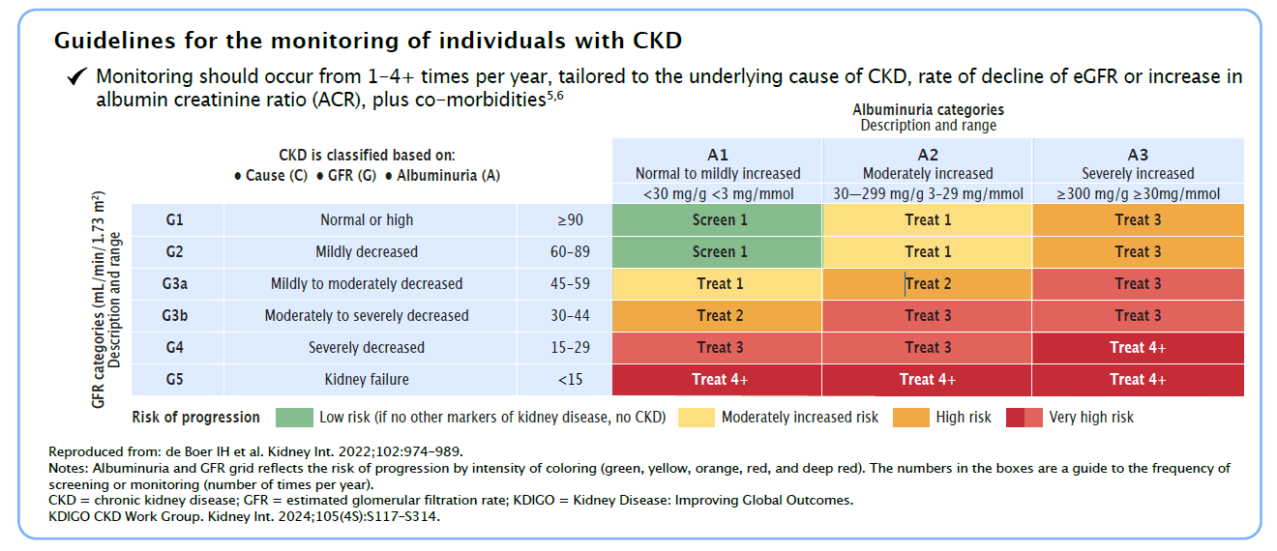
Potassium lowering strategies and therapies:
1. Address correctable causes of hyperkalaemia:
✓ Adjust potassium elevating drugs**⁴ – Prioritise those that can be swapped/withheld with least adverse consequences. Down-titrate/discontinue RAASi therapy as a last resort⁵
✓ Modify diet – Advise a healthy, diverse diet with higher consumption of plant-based foods than animal-based foods and low consumption of ultra processed foods.⁶ If potassium remains >5.5 mmol/L once non-dietary factors are addressed, refer to specialist dietician⁴
✓ Correct metabolic acidosis⁴ – Metabolic acidosis increases the risk of hyperkalaemia
✓ Optimise glycaemic control⁴ – Poorly controlled diabetes increases the risk of hyperkalaemia
✓ Avoid/address constipation⁴ – Constipation increases the risk of hyperkalaemia
2. Consider potassium lowering medications (acutely or longer term):
✓ Diuretics – Can increase potassium excretion
✓ Bicarbonate – Consider adding oral sodium bicarbonate if serum bicarbonate <22 mmol/L
✓ Potassium binders – Remove potassium from the body via the gastrointestinal tract⁴
3. Prevent recurrence of hyperkalaemia:
✓ Recurrence of hyperkalaemia should be anticipated, and steps taken to avoid it⁴
✓ Careful prescribing of potassium elevating drugs – use only where clearly indicated, with particular care if combinations are required, e.g. ACEi/ARB/ARNi + MRA for HF⁴
✓ Regular review of correctable causes and consideration of the need for potassium lowering medications (as above)⁴
✓ Regular monitoring of bloods (potassium and renal function) and review should occur at the frequency appropriate for the disease state and the individual, e.g. 1–4 times per year for CKD⁶ and HF¹, with additional monitoring during intercurrent illness (especially dehydrating illness), titration of medications that affect potassium levels or renal function, or change in the underlying cardiorenal condition
✓ Education of individuals with cardiorenal disease
⚒ Sick day guidance – A temporary pause of RAASi therapy, diuretics, metformin and sodium-glucose co-transporter-2 inhibitors during acute dehydrating illness may decrease the risk of AKI and hyperkalaemia. However, the evidence base for this is weak and there is potential for harm if these medications are not re-instated. Sick day guidance should be based on an individual risk assessment and there must be a clear plan to re-instate any paused medications.⁴,⁶

**Potassium elevating drugs⁴
• RAASi (ACE inhibitors, angiotensin II receptor blockers, mineralocorticoid receptor antagonists)  • Potassium supplements  • Potassium-sparing diuretics | • Trimethoprim/co-trimoxazole  • Nonsteroidal anti-inflammatory drugs  • Non-selective beta-blockers  • Antifungals | • Digoxin  • Salt substitutes  • Herbal medicines (e.g. alfalfa, dandelion)

RAASi therapy in the context of hyperkalaemia:
• Hyperkalaemia associated with RAASi use can often be managed by measures to reduce potassium other than down-titration or discontinuation of RAASi therapy⁶
• Down-titration or discontinuation of RAASi therapies is associated with adverse clinical outcomes in CKD and HF⁷–¹⁰
• Only down-titrate or discontinue RAASi therapy as a last resort; if hyperkalaemia is uncontrolled despite ‘Potassium lowering strategies and therapies’, or symptomatic hypotension or serum potassium >6.5 mmol/L (until normokalaemia achieved)⁶
• Re-initiate and re-optimise RAASi therapies that are down-titrated or discontinued once normokalaemia is achieved wherever possible – utilise appropriate ‘Potassium lowering therapies and strategies’
• If hyperkalaemia is preventing RAASi optimisation, seek specialist advice
• N.B. If RAASi therapies are discontinued, also discontinue potassium lowering therapies as appropriate
References:
1. McDonagh TA, Metra M, Adamo M, Gardner RS, Baumbach A, Böhm M, et al. 2021 ESC Guidelines for the Diagnosis and Treatment of Acute and Chronic Heart Failure. European Heart Journal. 2021;42(36):3599–726.
2. National Institute for Health and Care Excellence. Chronic Heart Failure in adults: Diagnosis and Management [Internet]. www.nice.org.uk. 2018. Available from: https://www.nice.org.uk/guidance/ng106
3. National Institute for Health and Care Excellence. Chronic Kidney Disease: Assessment and Management [Internet]. www.nice.org.uk. 2021. Available from: https://www.nice.org.uk/guidance/ng203
4. Alfonzo A, Harrison A, Baines R, Chu A, Mann S, MacRury M. Clinical Practice Guidelines: Treatment of Acute Hyperkalaemia in Adults [Internet]. UKKA. 2023. Available from: https://ukkidney.org/sites/renal.org/files/FINAL%20VERSION%20-%20UKKA%20CLINICAL%20PRACTICE%20GUIDELINE%20-%20MANAGEMENT%20OF%20HYPERKALAEMIA%20IN%20ADULTS%20-%20191223_0.pdf
5. de Boer IH, Khunti K, Sadusky T, Tuttle KR, Neumiller JJ, Rhee CM, Rosas SE, Rossing P, Bakris G. (2022). Diabetes management in chronic kidney disease: a consensus report by the American Diabetes Association (ADA) and Kidney Disease: Improving Global Outcomes (KDIGO). Kidney International, 102(5), 974–989.
6. Kidney Disease: Improving Global Outcomes (KDIGO) CKD Work Group. KDIGO 2024 Clinical Practice Guideline for the Evaluation and Management of Chronic Kidney Disease. Kidney Int. 2024 Apr;105(4S):S117–S314.
7. Kanda E, Rastogi A, Murohara T, Lesén E, Agiro A, Arnold M, et al. Clinical Impact of Suboptimal RAASi Therapy Following an Episode of Hyperkalemia. BMC Nephrology. 2023;24(1):18.
8. Epstein M, Reaven NL, Funk SE, McGaughey KJ, Oestreicher N, Knispel J. Evaluation of the Treatment Gap Between Clinical Guidelines and the Utilization of Renin–Angiotensin–Aldosterone System Inhibitors. The American Journal of Managed Care. 2015;21(11 Suppl):S212–20.
9. Linde C, Bakhai A, Furuland H, Evans M, McEwan P, Ayoubkhani D, et al. Real-World Associations of Renin–Angiotensin–Aldosterone System Inhibitor Dose, Hyperkalemia, and Adverse Clinical Outcomes in a Cohort of Patients With New-Onset Chronic Kidney Disease or Heart Failure in the United Kingdom. Journal of the American Heart Association. 2019;8(22):e012655.
10. Leon SJ, Whitlock R, Rigatto C, Komenda P, Bohm C, Sucha E, et al. Hyperkalemia-Related Discontinuation of Renin–Angiotensin–Aldosterone System Inhibitors and Clinical Outcomes in CKD: A Population-Based Cohort Study. American Journal of Kidney Diseases. 2022;80(2):164–73.e1.

Click here or scan the QR code to access the LOKELMA (sodium zirconium cyclosilicate) prescribing information.


Adverse events should be reported. Reporting forms and information can be found at www.mhra.gov.uk/yellowcard or search for MHRA Yellow Card in the Google Play or Apple App store. Adverse events should also be reported to AstraZeneca by visiting https://contactazmedical.astrazeneca.com or by calling 0800 783 0033.

